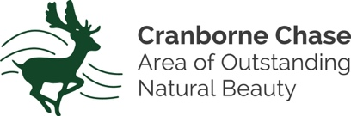
Volunteer Registration Form

In order to ensure you are covered under Wiltshire Council’s insurance for activities undertaken on behalf of the Chase & Chalke Landscape Partnership Scheme (AONB), please complete the following form and return as directed below.

Full Name(s):
Address:
Email:
Home Tel:
Mobile Tel:
Who would like us to contact in the unlikely event of an emergency?
Name:
Contact Tel:
Activities volunteered for: (eg. Walk Leader/Marshall, conservation work, species ID)

How did you hear/learn about the Chase & Chalke Landscape Partnership?

 | I would like to be added to the mailing list to receive the monthly (approx.) AONB email newsletter containing AONB and Landscape Partnership news, events and activities. I understand I can unsubscribe at any time. (Please tick to receive our email newsletter.)
Signed:* |  |  | Date:
*Electronic signature or printed name acceptable

Please return this form by email to: sarahforwood@cranbornechase.org.uk, or post to:
LPS Team, AONB Office, Rushmore Farm, Tollard Royal, Wiltshire, SP5 5QA

